**MONGODB AS PYMONGO**

**Importing**



**Setting up Server Connection**



**Creation**

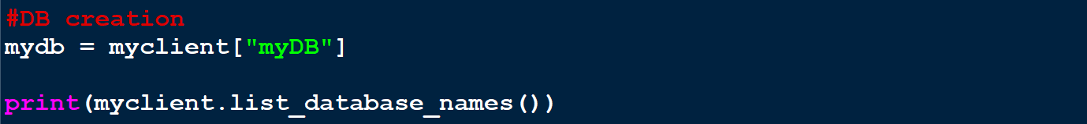

Smarter way to check DB existence:-

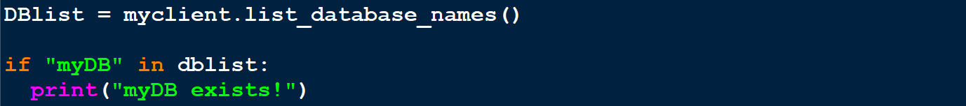

**Creating Collection**

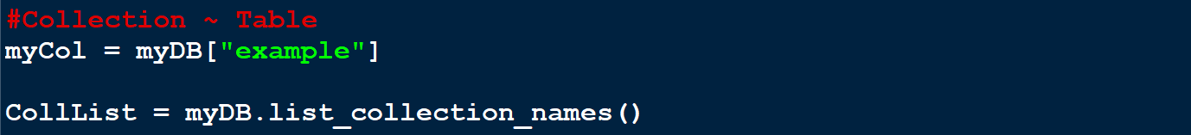

**Data Insertion**

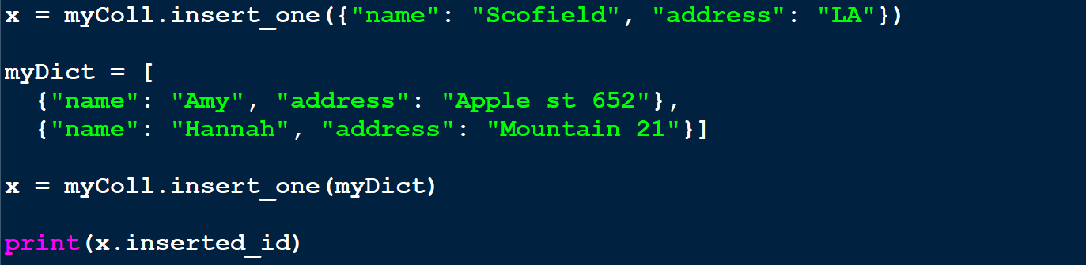

**Specific ID Dictionary**

* ***_id*** as a **key** in dictionary means you are providing an **ID** to records.



**Searching for Record Existence**



* Write a **particular value** for finding it in place of **0s** and **1s**.

**Finding for Certain Values**

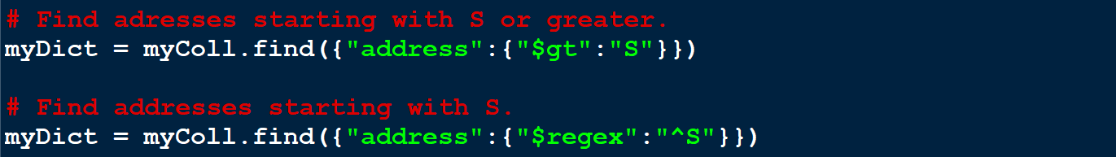

**Sorting**

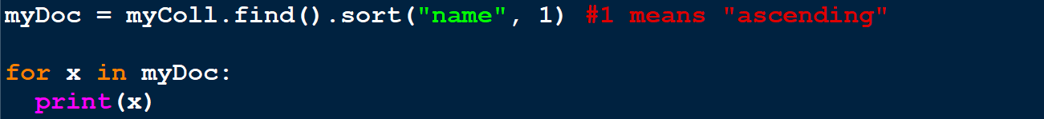

* Second parameter is **1 by default**.
* Similarly, we **-1** for **descending order**.

**Delete Records**



* The **condition** is written inside the parenthesis.

**Drop Collection**



**Updating Records**

For one record:-



For many records:-



**Limiting Records**

* Limiting the number of records.

